**LAB # 10**



**CSE301L Signals & Systems Lab**

Submitted by: **Maaz Habib**

Registration No: **20PWCSE1952**

Class Section: **C**

“On my honor, as a student of University of Engineering and Technology, I have neither given nor received unauthorized assistance on this academic work.”

Student Signature: ______________

Submitted to: **Engr. Durr-e-Nayab**

6/26/2022

**Department of Computer Systems Engineering**

**University of Engineering and Technology, Peshawar**

**Lab Objectives:**

Objectives of this lab are as follows:

* Fourier Series Representation of Continuous Time Period Signals
* Convergence of CT Fourier Series
* Properties of CT Fourier Series
  + Linearity
  + Time Shifting
  + Frequency Shifting
  + Time Reversal
  + Time Scaling

**Task # 1:**

In the above example, ak’s are chosen to be symmetric about the index k=0, i.e. ak = a‐k. Select new ak’s on your own to alter this symmetry and form the new signal. What do you observe? Is x(t) a real signal when coefficients are not symmetric?

**Observation:**

x(t) is a real signal when coefficients are not symmetric.

**Code:**

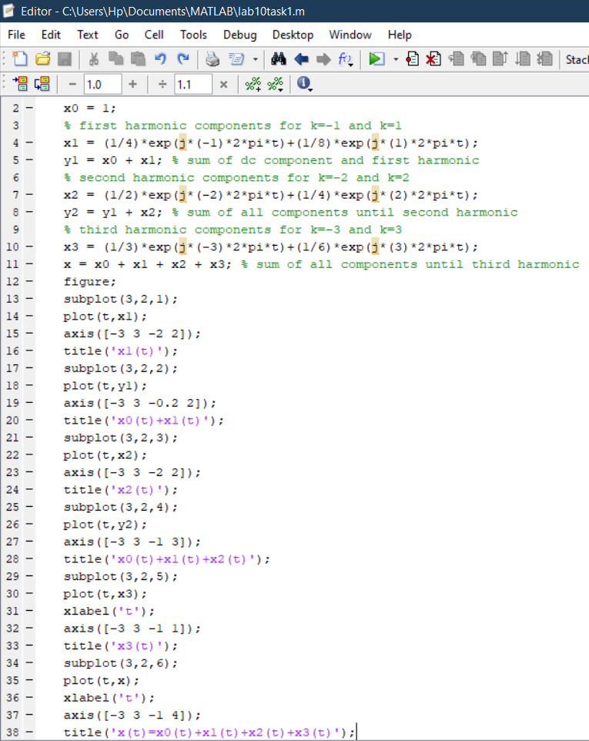

**Output:**

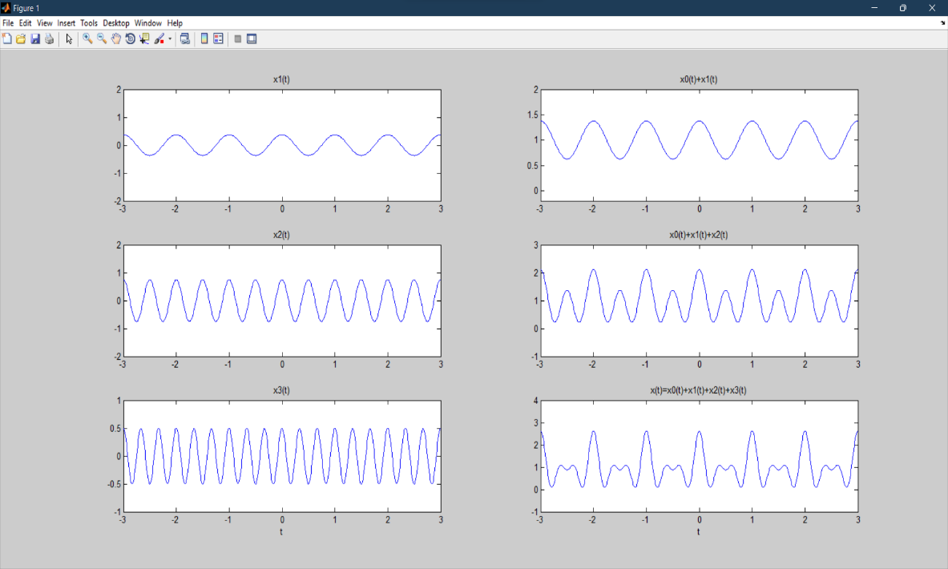

**Task # 2:**

A discrete‐time periodic signal x[n] is real valued and has a fundamental period of N = 5. The non‐zero Fourier series coefficients for x[n] are

a0 =1,a2 = a-2 = ej pi/4, a4 = a-4 = 2ej pi/3

Express x[n] as a linear combination of given coefficients.

**Problem Analysis:**

Change the coefficients of a0 to 1 and a2, a-2 equal to ej pi/4 and a4, a-4 equal to 2ej pi/3

**Code:**

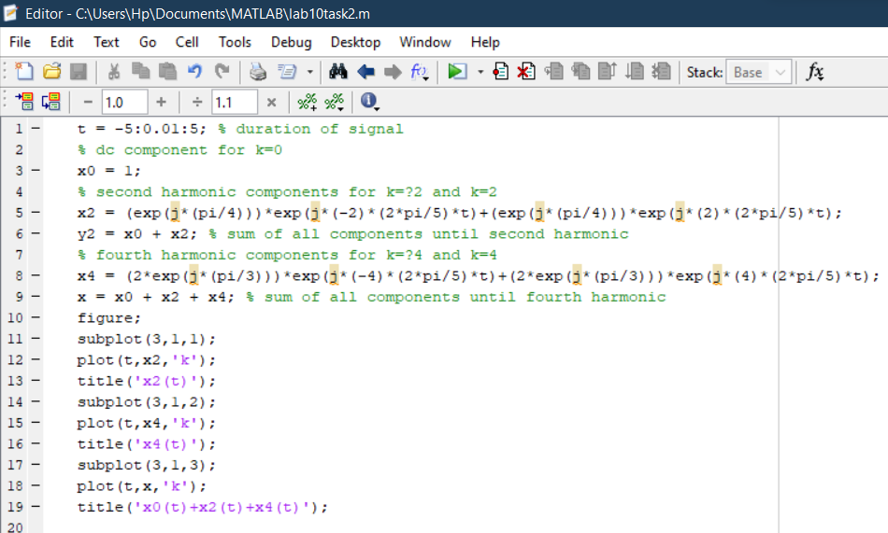

**Output:**

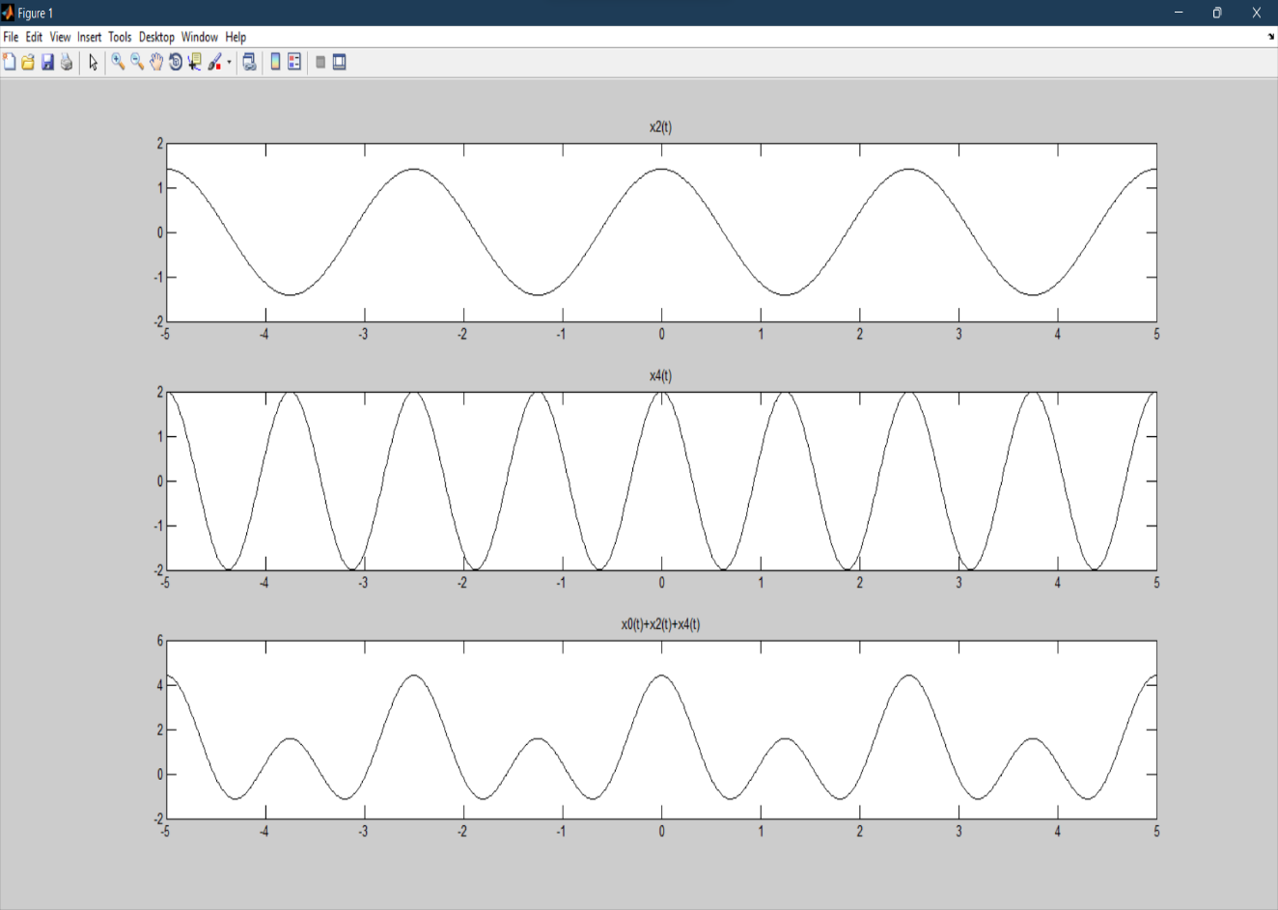

**Task # 3:**

Considering the FS coefficients plot given below, what do you observe happens to the envelope of the coefficients when T1 is reduced from 1/4 to 1/16 with constant time period T?

**Observation:**

As T1 is changed from 1/4 to 1/16 and we observe that the frequency of the wave decreases and time period increases.

**Code:**

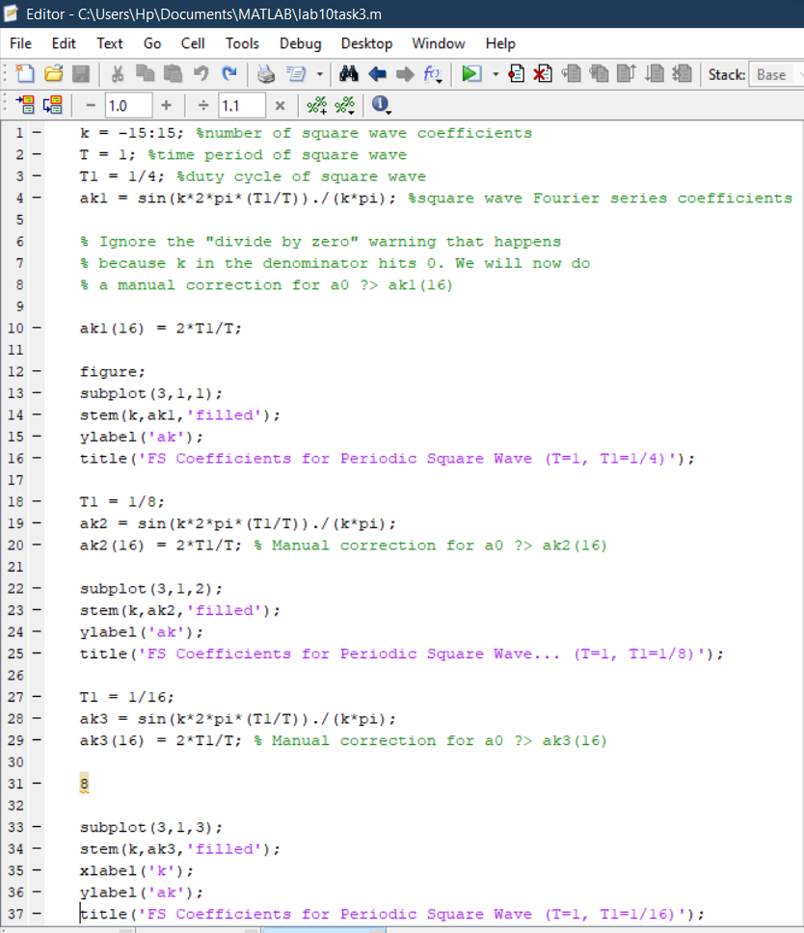

**Output:**

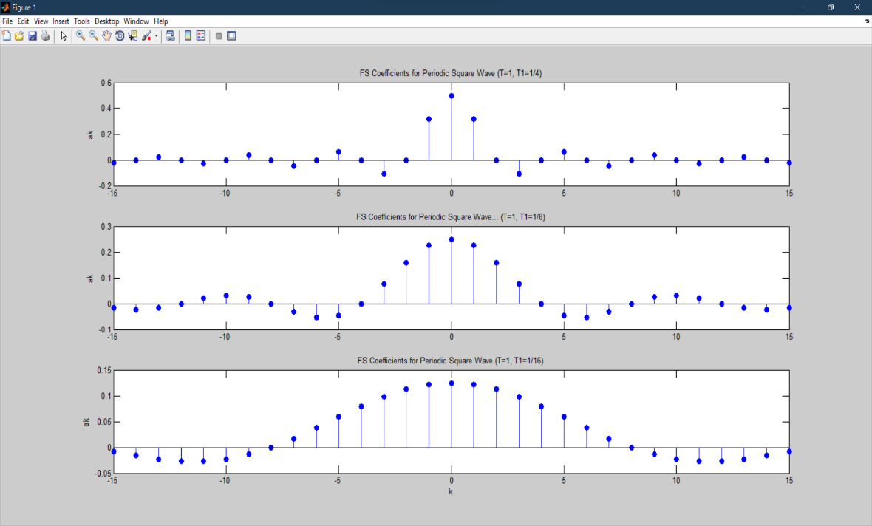

**Task # 4:**

Considering the plots of square wave reconstructed using M = 10, 20, & 100 terms above, what do you observe about Gibb’s phenomenon?

**Observation:**

As the number of signals to be added increases from 10 to 100 the square wave smoothens in form and is more defined.

**Code:**

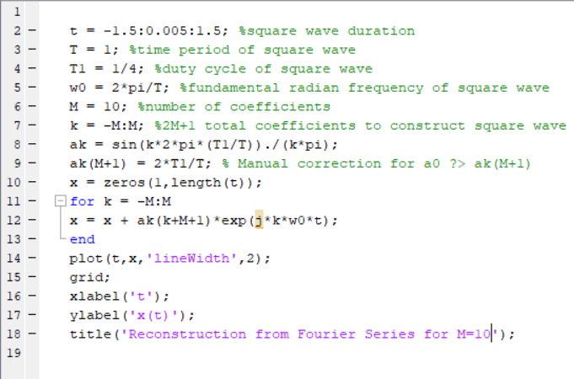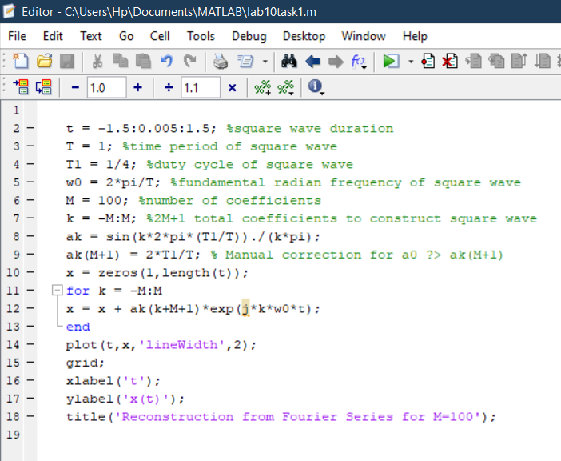

**For M=10 For M=100**

**Output:**

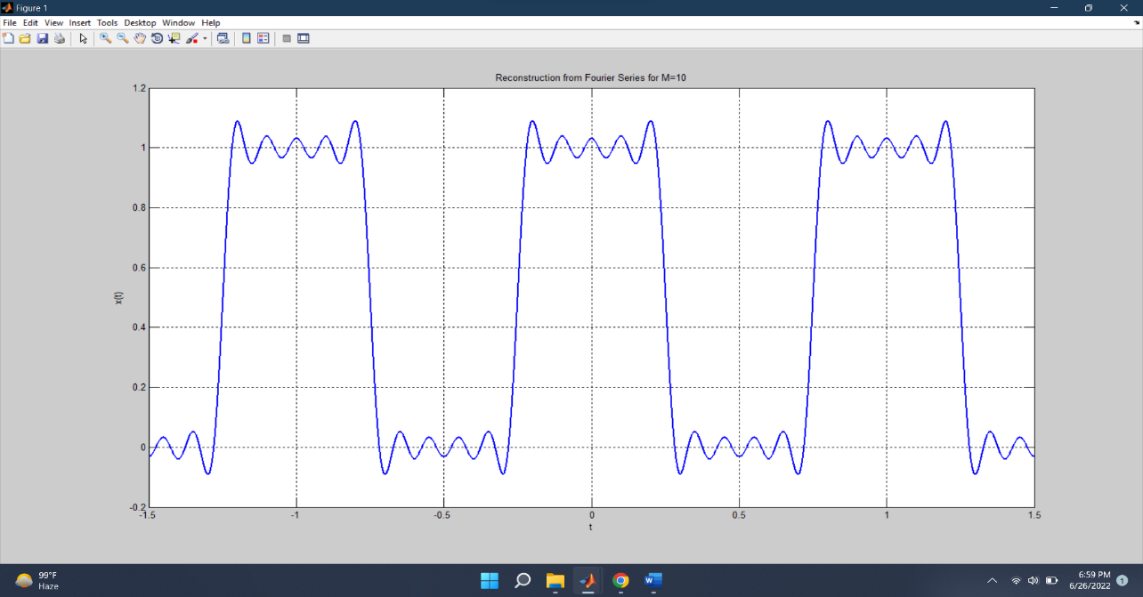

**For M=10**

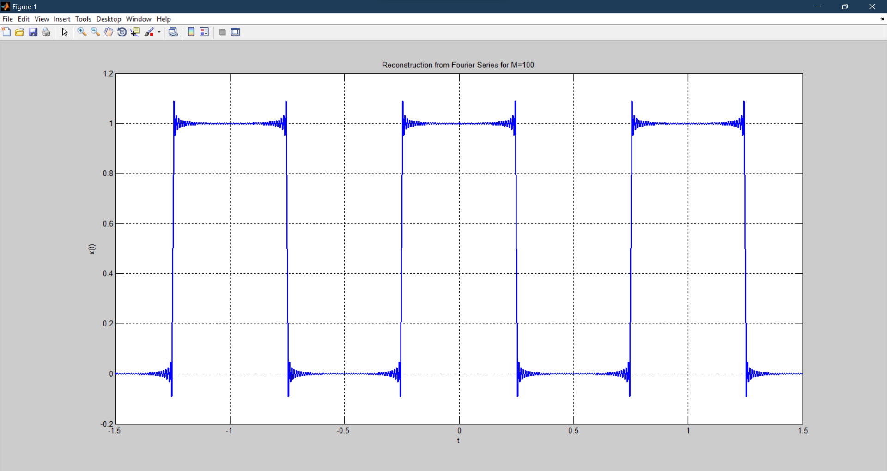

**For M=100**

**Task # 5:**

Given the following FS coefficients:



Plot the coefficients & reconstructed signal. Take the terms for reconstructed signal to be

M = 10, 20, & 50. What effect do you see when M is varied?

**Observation:**

As the number of signals to be added increases from 10 to 60 the wave smoothens in form.

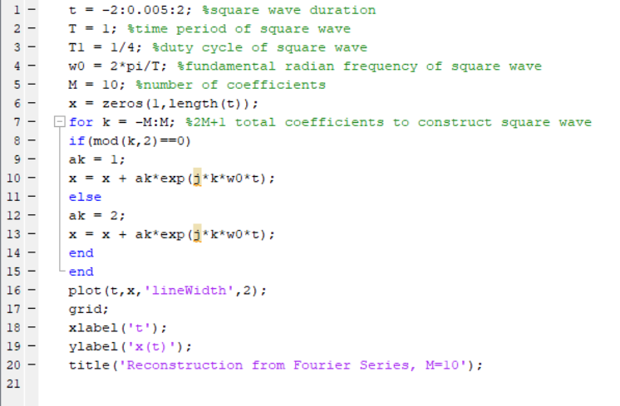**Code:**

**For M=10**

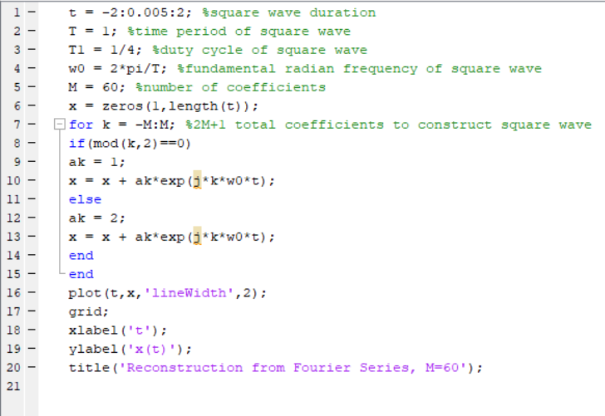

**For M=60**

**Output:**

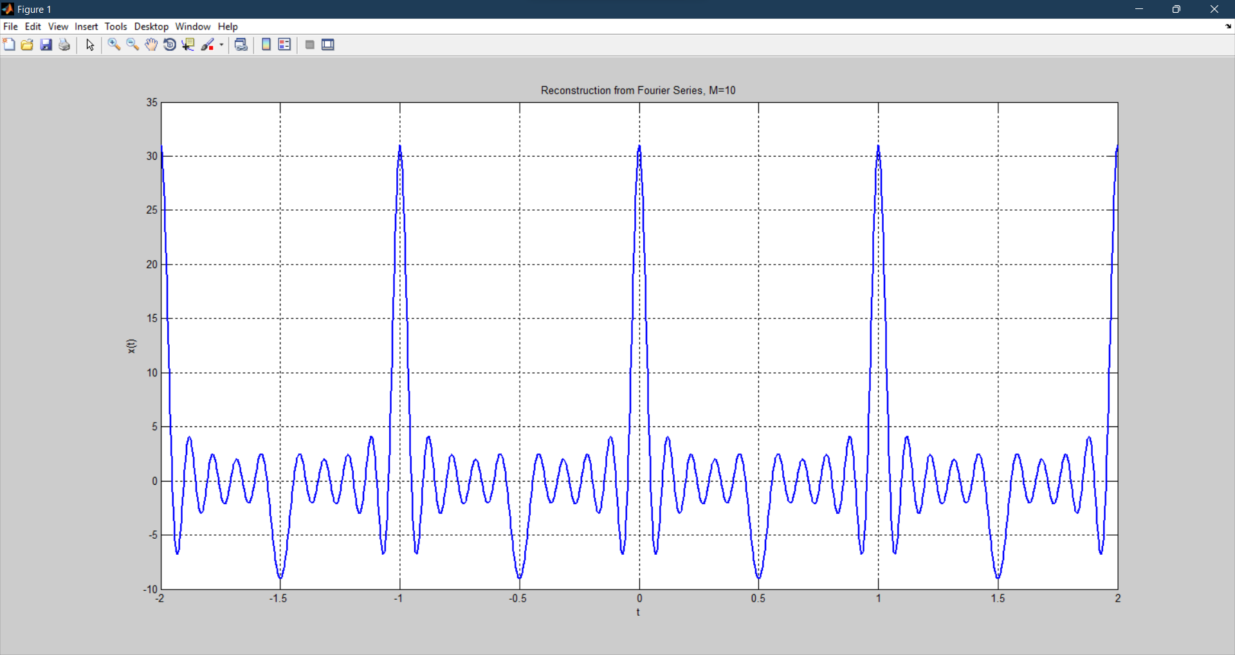

**For M=10**

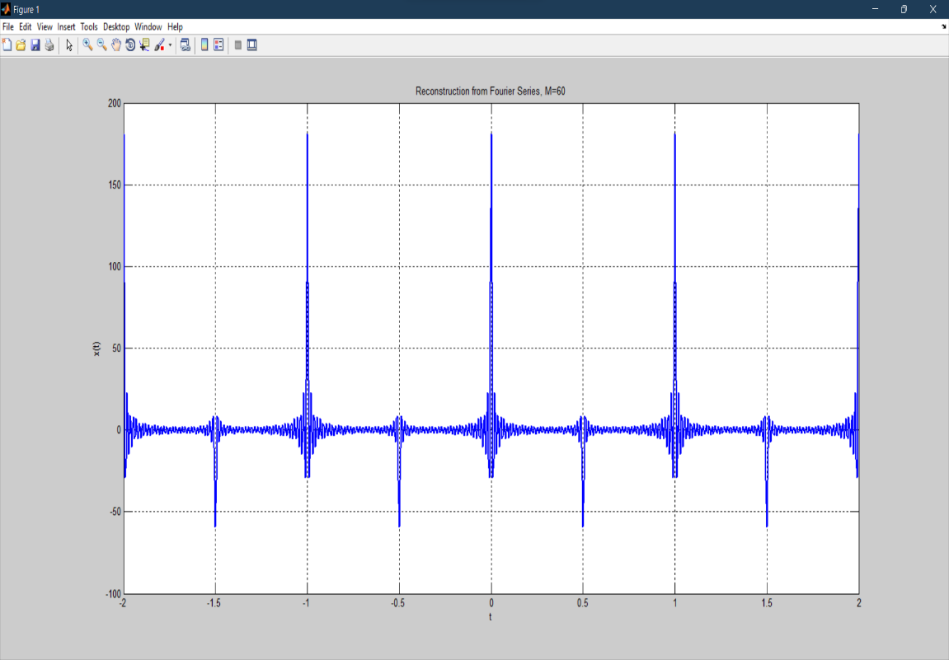

**For M=60**

**Task # 6:**

Given the following FS coefficients:

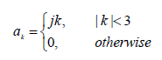

Plot the coefficients & reconstructed signal. Take 10 terms (M=10) for reconstructed signal.

**Problem Analysis:**

Take M equal to 10 and plot the signal.

**Code:**

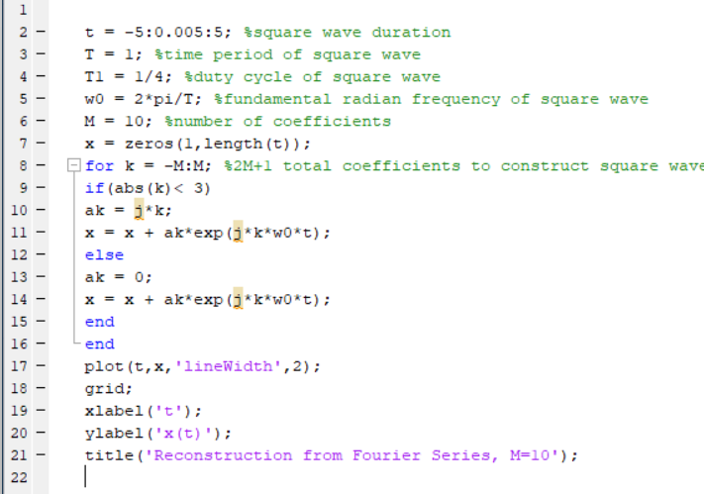

**Output:**

